create a timeline highlighting the key event, technological advancement and pivotal moment in the history of cyber security. this timeline will showcase how threat and defenses have developed over time

1960s: Birth of Cybersecurity & Networking

1940s–1950s: Early Concepts & Theoretical Foundations

1970s: First Attacks & Security Measures

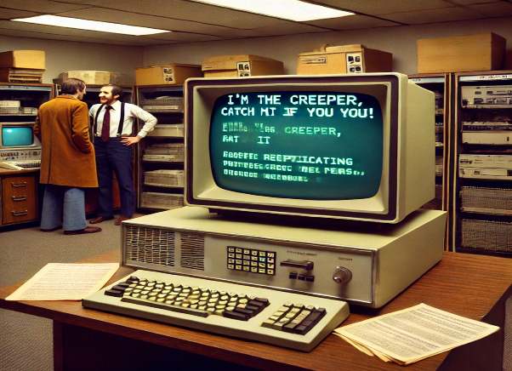

1980s: Rise of Malware & Cybercrime Awareness

.

1990s: The Internet Boom & Rise of Cybercrime

**2000s: The Age of Cyber Warfare & Advanced Threats**



2020s: AI, Cloud Security, & Zero-Trust Architecture

2010s: Nation-State Attacks & Cybersecurity Evolution

